Community Micro-Health Monitoring and Alert System for Early Risk Detection in Smart Communities
Saanvi Singh¹
School of Computer Science and Engineering, Vellore Institute of Technology, Chennai, India

Abstract – There is no continuous monitoring framework and real-time reporting mechanism, it is difficult to identify health risks at the community level very early. Traditional healthcare systems mostly rely on diagnosis that comes late, manual reporting, and reactive intervention, and it is these three that the effectiveness of the early response is greatly diminished, especially when there are disease outbreaks or individuals getting sick gradually are not known. This article recommends a Community Micro-Health Monitoring and Alert System, which is a web-based platform aimed at enabling proactive health surveillance in communities. The platform allows community members to regularly enter basic health parameters and symptoms through an easy-to-use interface. Besides, the system includes a rule-based risk assessment model that evaluates the entered data to classify individuals according to their risk levels such as low, medium, or high, which are determined by medical standards set in advance. The authors of the paper come up with a Community Micro-Health Monitoring and Alert System which is a web-based platform that helps communities to carry out health monitoring in advance. Through a user-friendly interface, citizens can frequently submit their basic health parameters and symptom data. A rule-based risk assessment model is part of the system to evaluate the gathered data and classify people as low, medium, or high-risk based on medical criteria set beforehand. When medium and high-risk cases are identified, the system automatically generates alerts and notifies the relevant healthcare bodies, thereby enabling them to take immediate measures and reduce the risks of serious health conditions.The article states that the system is designed with a full-stack architecture comprising three independent parts: a web-based user interface, a backend processing server, and a cloud database for efficient storage and access to data.
Keywords – Community health monitoring , Risk assessment, Real Time alert system, Public health Surveillance , Web based Platform , Healthcare analytics, Early Detection, Smart Healthcare Systems

I. INTRODUCTION
As population density is increasing rapidly and the complexity of public health issues continues to grow, the demand for efficient and quick healthcare monitoring systems has become more important than ever. Detecting health risks at an early stage grant a great benefit in terms of halting disease progression, cutting down healthcare expenditure, and alleviating the strain on medical facilities. On the other hand, a number of communities are still without a well-organized system for regular monitoring of peoples health, which in turn, results in late diagnosis and time of treatment.

Conventional healthcare systems generally respond to problems only when individuals get symptoms that are bad enough for them to seek help. This method greatly reduces the potential of prevention through early detection and thereby can lead to higher rates of illness and deaths. On top of that, those responsible for healthcare at a local level often do not have access to live data about health patterns of communities, which makes it almost impossible for them to recognize health dangers or disease outbreaks timely. Absence of a standardized framework for ongoing surveillance and decision-making through data exacerbates the problem.

As population density increases and the spectrum of public health problems getting more complex each day, having effective and rapid healthcare surveillance systems at our disposal becomes more necessary than ever. Detecting health risks at their initial phase can offer great benefits like the prevention of disease development, cost-saving in healthcare, and relief for medical facilities. Nevertheless, quite a few communities are still without a structured means for regular health monitoring of their residents which, in turn, results in delayed diagnosis and intervention. Typically, traditional healthcare systems only attend to the problems when people have symptoms that are severe enough to prompt them to seek help.

Several times we have witnessed through the research that this method raises the risk of missing the diseases by early diagnosis and therefore the end result might be the increase of sickness and death. So, it is quite challenging for them to detect a health threat or outbreak of a disease in time. Actually, one of the causes of this difficulty is the lack of a well-coordinated system of periodic surveillance combined with data-driven decision making.

This initiative is at the crossroads of various interdisciplinary domains such as smart healthcare systems that use technological tools to enhance healthcare services delivery; preventive medicine that through early detection and treatment focuses on preventing diseases; and community health informatics that deals with gathering, analyzing and using health data for the whole population. By bringing together these areas, the solution presented intends to pave the way for the creation of comprehensive and effective healthcare monitoring systems that will be able to tackle the current public health issues.[1] [2]

A. Background Motivation
The Community Micro-Health Monitoring and Alert System that is being proposed is based on multiple technology ideas that collectively help in tracking health continuously, managing data efficiently, and delivering healthcare timely. The primary part of the system is digital health monitoring. It continuously collects and manages health-related data like body temperature, blood pressure, and usual symptoms by employing software-based platforms. Unlike traditional healthcare approaches relying on periodic doctor's visits, digital monitoring enables real-time data collection and analysis which can facilitate early diagnosis and reduces diagnostic delays. Besides, classification of risk systems plays a very significant role in assessing how serious a person's health condition is. Generally, these systems take a user's data and use several simple rules and thresholds to assign the user to the low-risk, medium-risk, or high-risk category.

To make this risk classification work more smoothly and effectively, the proposed system has a rule-based risk assessment system automated. This will support automated decision-making and case prioritization for emergency response. Besides, this platform is a web-based information system. That means the users can just use the platform from the web browsers they normally use without downloading any special software.

The clientserver framework maintains a continuous exchange between the frontend presentation and backend server, thereby streamlining the frontend user input handling and backend data modification processes. The employment of remote database services as an integral part of the system accentuates its potential through offering elastic, safe and simultaneously updated data saving capabilities. The cloud setup provides dependable data accessibility, thus healthcare organizations can retrieve refreshed data at any time from anywhere. Besides, a vital element of the system is the self-acting alert system that assesses newly arrived data at all times and issues notices when set risk levels are exceeded.

With this, the director of the medical institution does not require to be present all the time for the purpose of monitoring additionally they will always be informed of the medium and high-risk cases. By harnessing these key principles, the system under consideration sets up an all-inclusive mechanism for community-level health checkup. Distributing them at a local level, it makes a data gateway, analytical engine and updated reporting tool available to medical personnel and the health officials thereby supporting comprehensive medical vigilance. The redesign of these methods in an unsophisticated manner and their subsequent combination give rise to a community health care system that is both easily one that continues in existence and can be employed on a large scale.[2] [3]

II. PROPOSED SYSTEM
1.System Overview
The Conceptual Community Micro-Health Monitoring and Alert System is a web-based platform that aims to support a continuous health tracking at the community-level. Through the system, citizens are able to submit their basic health parameters like body temperature and symptoms at the intervals that are convenient to them using a simple user-friendly interface. The backend server that analyses the user data in real-time then carries out the risk level determination of each individual in accordance with medical criteria set beforehand. The health-related data that has been through the processing is then saved securely in a cloud database from which healthcare officials can retrieve it and use it for monitoring changes in health patterns of the community. Besides, this system has a feature whereby an automated alert is sent to the concerned persons whenever an unusual health condition is identified thus facilitating a prompt response..

2.Motivation and Novelty
The main reason of the proposed system is to enhance the capability of conventional healthcare systems which mainly depend on reactive methods and diagnosis delays. These systems, for the most part, are not equipped with real-time monitoring features and do not offer actionable insights for early community-level intervention. The uniqueness of this paper is that it combines in one easily accessible platform continuous health surveillance, risk assessment through rule-based system, and automatic alert generation. Comparing to the traditional methods, the present proposal is more concerned with the prevention of the health problems providing the possibility of the earliest risk detection through the constant data gathering and examination. Also, the system has been made with the community-level implementation in mind which means that it is scalable, cost-effective and can be easily implemented in various settings.

3.System Architecture
The main components of the system a client-server model mainly divided into a few layers with a few main parts including user frontend interface, the backend processing server, and the cloud database. The users interact with the program through a frontend interface, which is a web-based platform that allows the user to easily enter their health data and see their health status. Backend server is the same backend server side framework through which data gets processed, risk gets analyzed and different components of the system communicate with the server. Also, the server uses a set of rules for categorization of health risks and alerts when necessary. The cloud database is the place where all data related to users are stored, risk classifications and alert logs are kept to ensure that data is available, scalable, and secure. The whole system is designed in this way to ensure good performance and comfortable usage.

4.System Workflow
The Workflow starts with registering and authenticating the user, then the citizens can send their daily health parameters using the web page. The data after submission will be the to the backend server, where it will be validated and analyzed. Risk assessment module compares the input data to the predetermined thresholds and then determines a risk level. According to this, the system modifies the database and, in case of medium or high-risk, generates alert. These alerts are shown on the admin console, so that health workers can respond timely. The system is always refreshing data, based on this data nowadays it is possible to do dynamic monitoring and track changes in health status of a community.

5.Benifits of the Proposed System
The system has many benefits compared to the usual ways of healthcare. With the help of the new system, it is possible to constantly watch over one's health, which in turn can help to know about the health risks in advance. Moreover, the alert system that is automatic can always be a way to send messages at the right time between the citizens and the doctors or other healthcare givers which, in turn, help to lessen the waiting time for medical help. Besides, the usage of the cloud database assists in effective management of the data and also the system can be easily scaled up for handling larger population groups. Furthermore, the system is designed to give the users updated information via dashboards which in turn can be a really good support for the health department to make wise decisions. Last but not least, since it is a web-based system it is not tied to any one type of device; therefore, it is very handy for the users to keep up with the health checking at regular time.

6.Expected Impact
The deployment of this planned system will greatly boost healthcare management at the community level. The system will facilitate early diagnosis and quick action, therefore lowering the transmission of diseases and the occurrence of serious health problems. It strengthens the relationship between residents and medical officials, which results in a better use of healthcare resources. Besides, the system makes digital decision making easier by giving immediate information about health trends in the community. On the whole, this is a very comprehensive system that can be integrated within the future healthcare framework to help communities be healthier and less prone to ailments.

III. SYSTEM ARCHITECTURE
A. Architectural Overview
The suggested Community Micro-Health Monitoring and Alert System is based on a multi-layered client-server design that can effectively manage data gathering processing storage, and live monitoring. The system's architecture is breaking down into separate components, which facilitates independent development and the scalability of parts.

Each layer executes a specific function while also communicating with other layers in a smooth manner through standard interfaces.

The system is roughly segmented into the following layers:
- User Layer (Citizens and Healthcare Authorities)
- Presentation Layer (Frontend Web Interface)
- Application Layer (Backend Processing Server)
- Processing Layer (Risk Assessment Engine)
- Data Layer (Cloud-Based Database)
- Alert and Monitoring Layer (Notification & Dashboard System)

Employing this layered method system provides working flexibility, the ability to maintain the system efficiently, and good performance of the system under various conditions.

B. User Layer (Citizen & Healthcare Users)
The user layer is the main interaction point of the system and consists of two types of users: citizens and healthcare authorities. Citizens are expected to report their daily health measurements like temperature, symptoms, and overall health status. Healthcare authorities however get into the system via an admin panel to keep an eye on health patterns and react to warnings. This layer focuses on user-friendliness and being easily reachable to attract the highest number of participants and get precise data input.

C. Presentation Layer (Frontend Interface)
The presentation layer is a web based interface developed with Html, Css and Js technologies.
It offers users a friendly and well organized platform for interaction and user activity.
- User registration and authentication
- Health data submission forms
- Dashboard visualization of personal health status
- Navigation across system features

The frontend sends/gets data to/from the backend server through the use of RESTful APIs. This ensures efficient data transfer and real-time refreshing of the user interface. Besides, the design of the platform is adaptive and simple to operate on different devices a user might have.

D. Application Layer (Backend Server)
The application layer serves as the main processing unit of our system.Its Implemented using a serverside framework such as Node.js with Express, it will handle all incoming requests from the frontend and its primary responsibilities include:
- Request handling and routing
- Data validation and preprocessing
- Communication with the database
- Integration with the risk analysis module
The backend ensures secure and efficient handling of user data while maintaining system integrity and performance.

E. Processing Layer (Risk Analysis Engine)
The processing layer is the intelligence component of the system, responsible for analysing health data and determining risk levels. It employs a rule-based approach where predefined thresholds are used to evaluate parameters such as temperature and symptoms. Based on the evaluation, individuals are classified into:
- Low Risk: Normal health conditions
- Medium Risk: Mild symptoms requiring observation
- High Risk: Severe conditions requiring immediate attention
This classification directly influences the alert generation mechanism and enables prioritization of healthcare responses.

F. Data Layer (Cloud Database
The data layer uses a cloud database system such as Firebase Firestore to store and manage the data of the entire application. This involves the points below:
- User profiles and authentication data
- Daily health submissions
- Risk classification results
- Alert logs and system activity

G.. Alert Generation Module
The alert system keeps a close eye on the results of the risk assessment engine non-stop. Once it decides a user is in the medium or high risk category, an immediate alert is generated by the system.
These alerts include:
- Sent to the admin dashboard
- Logged in the database for tracking
- Highlighted for priority attention

The use of this automated system means there is no requirement for a manual check, and the response time is drastically shortened as well.

H.. Momotoring and Analytics Module (Admin Dashboard)
The administrator dashboard is a unified platform that healthcare authorities utilize for oversight and monitoring of community health information. It allows:
- Real-time patient tracking
- Visualization of risk levels
- Alert management system
- Statistical insights and trends

This module helps making decisions more effectively by delivering the results that can be acted upon and at the same time, it stays supportive in the proper and targeted utilization of healthcare resources.

H.. Architectural Advantages
The system architecture presented here is capable of delivering numerous major benefits that would make it more suitable for implementation in community healthcare on a large scale. A major aspect that stands out is the scalability of the system since the adoption of cloud-based infrastructure makes it possible to very effectively handle the increase in the number of users without performance degradation. This is an important aspect because it means the platform can be rolled out in various communities and scaled up whenever necessary. Modularity is also a very important feature of the system as it is broken down into separate functional units of work such as frontend interface, backend server, risk analysis module, and database. Furthermore, this arrangement makes it easier to keep the system up-to-date and also supports the introduction of new features without causing any disruptions to the already existing ones. Besides, this architectural framework is capable of handling real-time interaction which means that users' health data can be analyzed and categorized almost immediately, thus allowing fast identification of possible health hazards and timely intervention.Besides that, by using central data management, the system builds a high degree of reliability. It means that all data are kept safe in a cloud database, which not only maintains data consistency but also ensures their availability and fault tolerance.

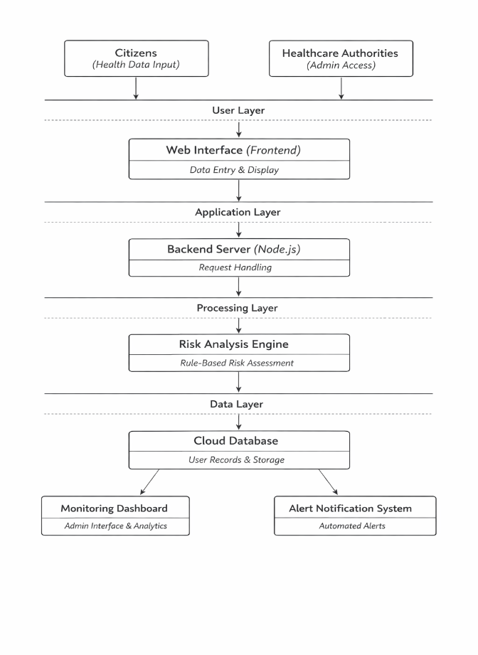
Fig. 1. System Architecture Diagram

VI PROTOCOL STACK
The Community Micro-Health Monitoring and Alert System to be implemented is planned to use a layered protocol stack to make sure that communication will be efficient, data transmission - reliable, data handling - secure, and the system components interaction - smooth. The protocol stack's design is based on the standard web communication models and it is partitioned into several layers, where each layer is assigned a particular function within the system. Together, these layers facilitate a well-organized data flow starting from the user interface and ending at the backend server and cloud database, thus delivering accuracy, scalability, and performance..

A. Application Layer
The application layer is the main center of interaction between users and the system, allowing them to work with the platform direct. It has the the web frontend that patients use to enter their health data and that healthcare personnel use to track system reports. This layer has to renders user dashboards, processes data forms , and shows real-time responses like risk levels and warning messages. Because built on modern web technologies, this layer guarantees that the application is accessible, works well, and is easy to use on various devices. Additionally serving as a structured and user-friendly interface, the Application Layer is fundamental to securing user involvement and data correctness, therefore also establishing the basis of the system's next operations..

B. Presentation Layer
The presentation layer not only takes care of the look and feel of the data but also its changes. It ensures that different parts of the system speak the same language. For example, it changes various forms of user inputs to a standard format like JSON before sending it to the backend. In addition, at this level, the processes of encoding and decoding the data also take place so that the message gets through in a sensible and consistent manner. Furthermore, it may have some simple checking and formatting functions to help in safeguarding data integrity and minimizing errors during data interchange. By setting a common ground for how data is represented, the presentation layer guarantees a seamless exchange of information between the frontend and backend.

C. Processing Layer
The Processing Layer is the main engine of the system. It is here where the data is analyzed and explanations are drawn. This layer has a risk assessment engine that evaluates the health parameters submitted by the users, compares them with rules and thresholds. Based on the health risk assessment, individuals can be classified as low, medium, or high risk. This is the layer that implements the system's decision-making logic. So for instance, it can be the alerting or the record updating within the system. When coupled with the processing layer carrying out instant analysis, identification of possible health risks will not be delayed. It would be a mistake to overlook the processing layer's life-saving function.

D. Data Layer
Data Layer picks up the role of storing, organizing, and retrieving all the system data. Example: It uses a cloud database to save users' details, medical records, risk factors, and emergency logs. This part of the system manages to keep the data consistent, available, and able to grow, thus it makes the system ready for a great number of users at the same time. Employing rapid data access methods, the healthcare staff gets the freshest data at their fingertips. At the same time, highly secure data storage practices are implemented to safeguard patients' sensitive health information. Besides that, the data layer is the very pulse of the system, driving both the operational and analytical aspects.

E. Alert Layer
The Alert Layer is responsible for creating and sending notifications that are generated from the outputs of the processing layer. For instance, if the user is identified as medium or high risk, this layer is the one that initiates alert messages that are sent to healthcare authorities via the admin dashboard. In other words, it guarantees the distribution of important information at the right time, thereby facilitating quick response and intervention. Besides that, the alert layer runs by itself which means that users no long need to manually monitor the system constantly and this leads to a reduction in time needed for making decisions. Through delivering instant alerts, it makes a very big contribution to the promptness and efficiency of the whole system.

F. Physical Layer
The physical layer is the lowest layer in a protocol stack responsible for the actual transfer of raw data through the physical medium. This layer usually includes hardware elements like network cables routers wireless signals, and other communication devices. It converts digital data into electrical or wireless signals for transmission over the communication medium and ensures that the data is physically delivered from the client device to the server system.

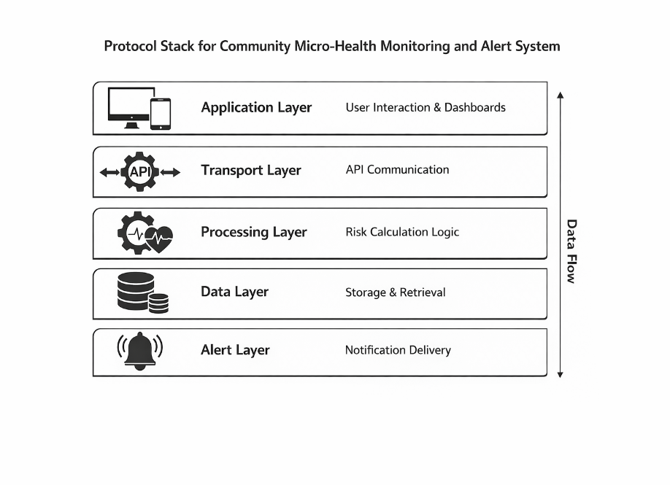
Fig. 2. Protocol Stack for Community Micro Health Monitoring System

VI EXPERIMENT SETUP
A . System Overview
The proposed Community Micro-Health Monitoring and Alert System experimental setup aimed to test the system's capabilities, dependability, and live response in a simulated community environment. The system was developed as a comprehensive web application combining a user interface, server for backend tasks, and database hosted on the cloud. The main goal of this setup was to assess the system's performance in gathering health information of users, analyzing it by means of a rule-based model, and issuing alerts according to the level of risk.

The implementation is based on the client, server architecture which includes:

Frontend (Client Layer), this is responsible for the user interface and interaction.

Backend (Application Layer), this layer is dealing with authentication, API logic, and business rules.

Database (Data Layer), a cloud database is used to store the user credentials and trusted contact information.

The system architecture is illustrated conceptually as:

[User (Citizen)]
↓
[Health Data Input Interface (Frontend)]
↓
[API Request (HTTP/HTTPS)]
↓
[Backend Server (Node.js / Express)]
↓
[Data Validation & Processing]
↓
[Risk Assessment Module (Rule-Based Logic)]
↓
[Alert Triggered]

B. Data set Description

The system works independently of any external or pre-existing datasets.
It is a synthetic dataset that was manually composed to imitate real-life user interactions:
- Body temperature readings
- Presence of symptoms such as cough, fatigue, and discomfort
- General health condition inputs

Several test cases were developed to depict different user scenarios ranging from completely healthy to very sick individuals. This technique gave the system an opportunity to be thoroughly tested not only in risk classification but also in handling heterogeneous input conditions.

C. Risk Assessment Model
The system uses a rule-based risk classification model in the backend. This model assesses health data provided by users by comparing it with preset standards for risk levels to classify them as:

- Low Risk: Healthy and no clear signs of illness
- Medium Risk: Mild symptoms or slightly abnormal
- High Risk: Severe symptoms or critical health

The rules originate from basic medical reasoning, e.g. an increase in temperature plus a number of symptoms leading to a higher risk. This model allows for quick calculations, minimal complexity, and instant responses, thus being a perfect fit for community-level deployment where advanced machine learning is not a must.

D. Software Tools and Technologies
The system was constructed by combining a variety of modern web technologies to making sure it functioned and could be scaled:

Frontend: For designing user interfaces such as sign in pages, dashboard and health data submission forms HTML CSS, and JavaScript were employed.

Backend: Server side logic, API routing and data handling was taken care of using Node.js coupled with Express framework.

Database: User profiles, health data, and alert logs were stored in cloud-based NoSQL database Firebase .

API communication: RESTful APIs were utilized for the communication between the frontend and backend components which have been developed accordingly. [4]

E. Hardware Environment
The system underwent testing on a standard personal computer with moderate specifications, including:
Processor: Intel i5 or equivalent
RAM: 8 GB
Operating System: Windows
We ran the backend server locally, but for the database, we used the cloud hosting on Firebase. A web browser (Google Chrome) served as the frontend access tool and user interaction simulation environment..

F. Experimental Procedure
Multiple test scenarios have been performed to assess the system by inputting different combinations of health parameters through the user interface. The steps were:

- Registering and logging into the system
- Submitting health data through the input form
- Sending data to the backend via API calls
- Processing data using the risk classification module
- Storing results in the cloud database
- Triggering alerts for medium and high-risk cases
- Displaying outputs on the admin dashboard

Every step was tracked to make sure the system was working properly and the data was flowing correctly.
.
G. Performance Evaluation
The system's evaluation criteria were mainly focused on the following points:
- Accurately classify user health data into appropriate risk categories
- Process inputs in real time without noticeable delay
- Store and retrieve data efficiently from the cloud database
- Generate alerts promptly for critical cases
- Display real-time updates on the admin dashboard

The results indicated that the system successfully performed all required operations, demonstrating effective integration of frontend, backend, and database components.

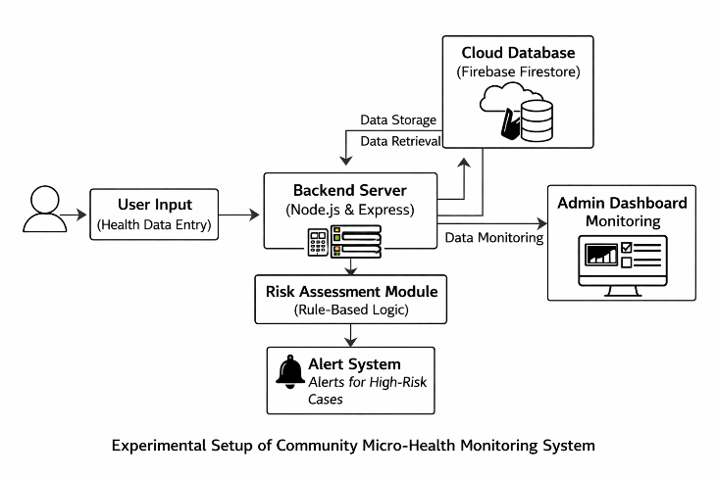
Fig. 3. Technical Setup Architecture Diagram

VII EXPERIMENTAL RESULTS AND SYSTEM OUTPUTS
The Community Micro-Health Monitoring and Alert System proposed was finally realized in the form of a full-stack web application that combines frontend, backend, and cloud-based database parts. The system has been carried out in a simulated environment where a number of users input their health data, and the system was able to automatically process the data, classify it, and produce the alerts. The findings show the proper operation of all the main modules, e.g. acquisition of data, classification of risk, storage, and generation of alert.

A . User Login Interface
The login interface grants secure system access only to registered users. It authenticates the username / password combination and creates a user session for the rest of the interaction. This is proving the successful installation of the authentication module.

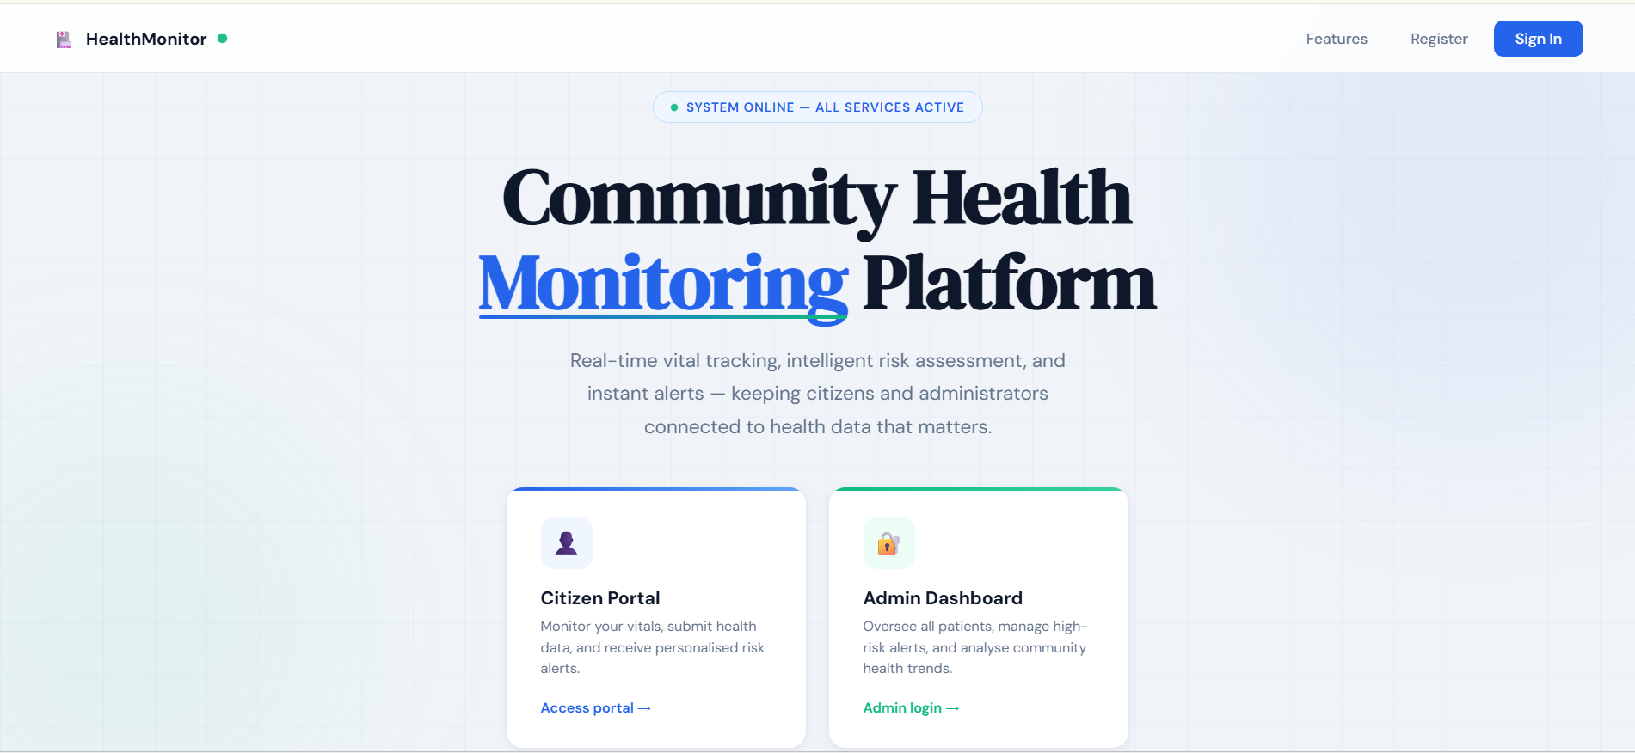

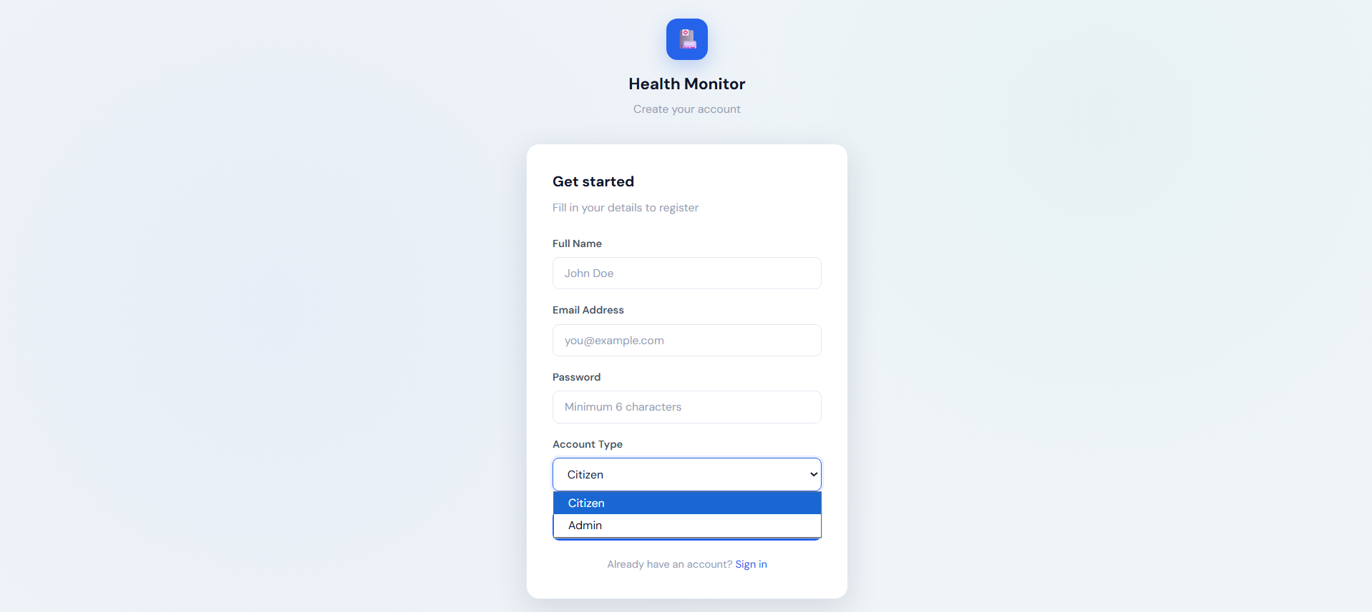
Fig. 4. User Login Interface

B . System Dashboard
The dashboard is the main hub from where the user can, {split} directly or indirectly, operate health monitoring tools. The design of the interface is neat and intuitive so that the users don't have to struggle while going through the health features section

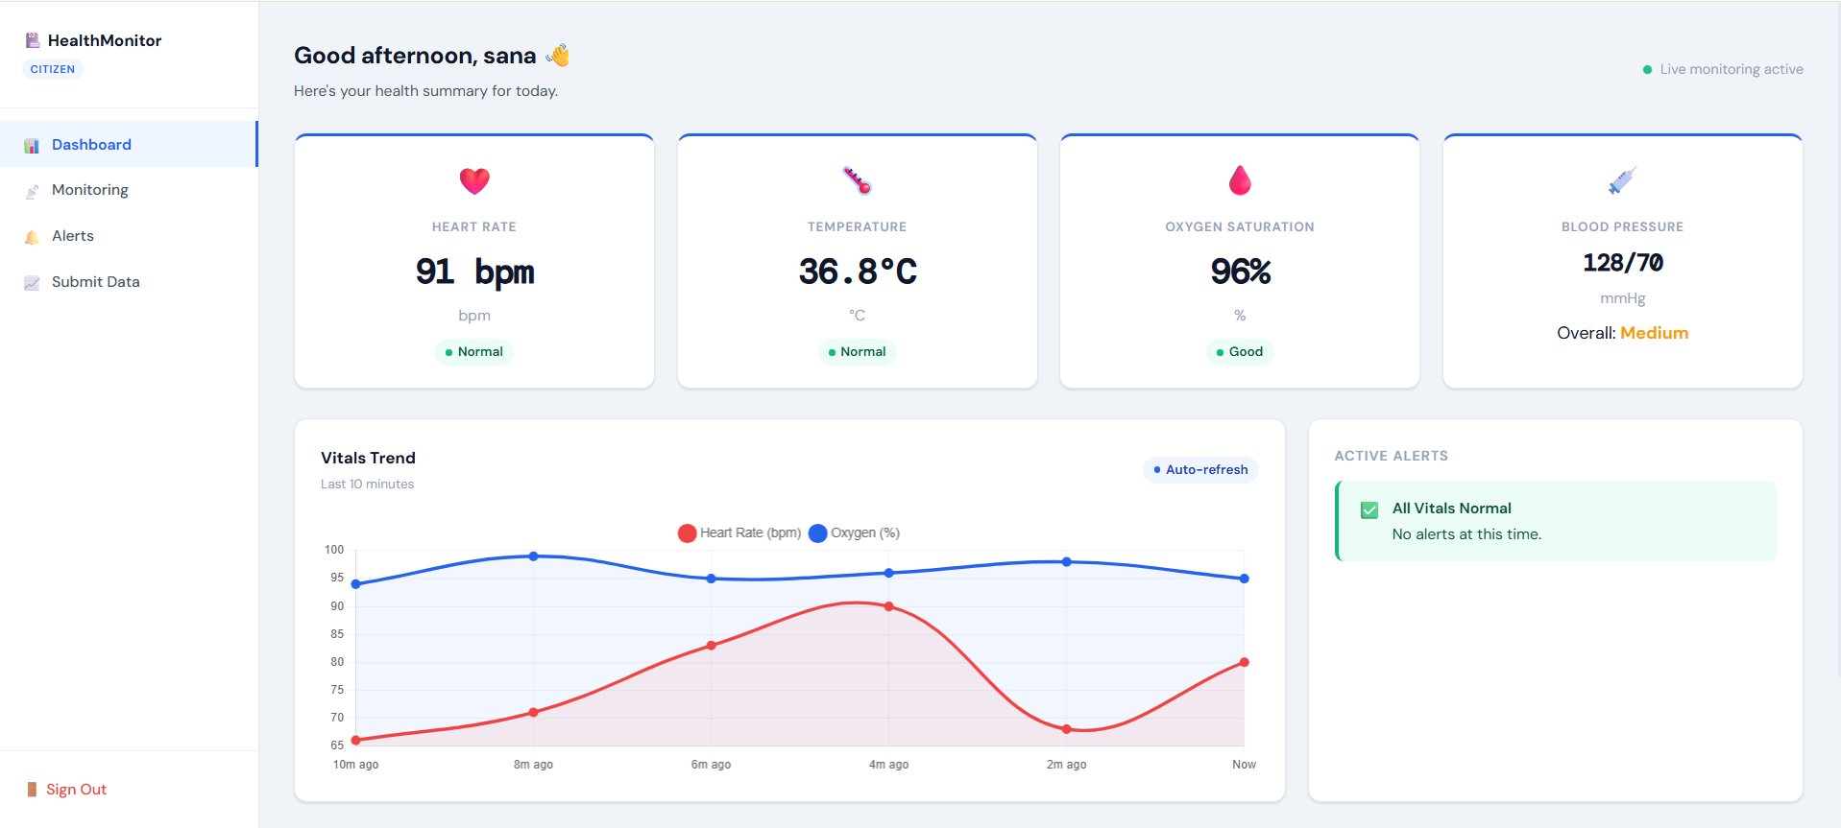
Fig. 5. User Citizen Dashboard

C . Health Data Input Form
The platform offers an interface for the users to report their health parameters such as temperature and symptoms. The frontend collects this information in a consistent format and then sends it to the backend server for further work. The green light on successful submission shows that frontend-backend integration is right.

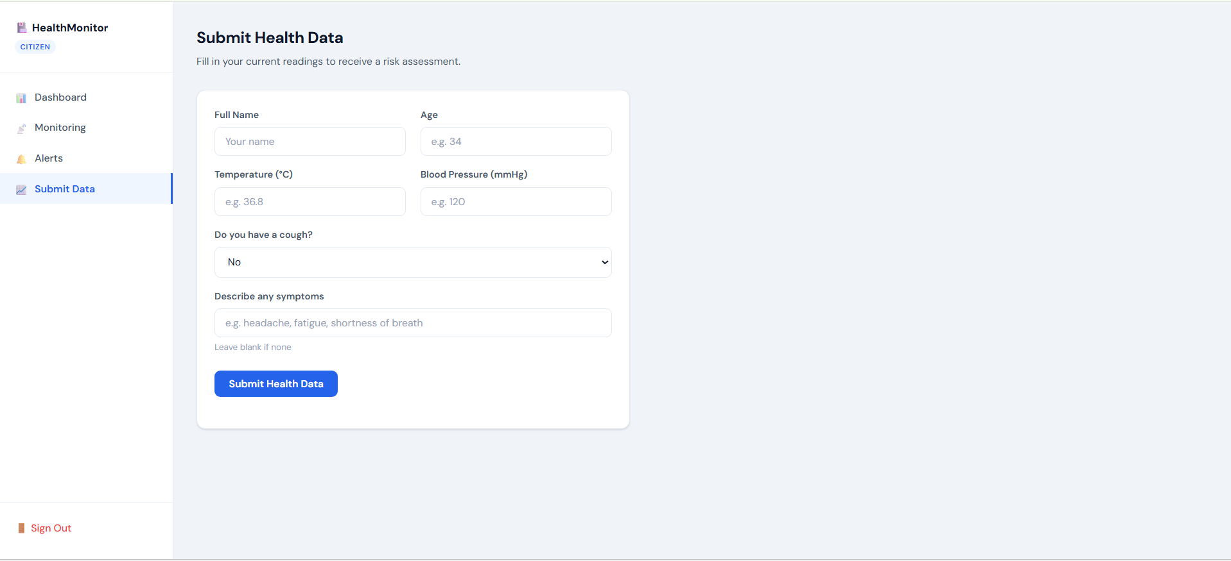
Fig. 6. Health Data Input Form

D . API Response / Console Log
The backend server handles user input coming via API calls and runs it through the rule-based risk model. The result is an output containing the risk level allocated to the user which shows the correct implementation of server side logic.

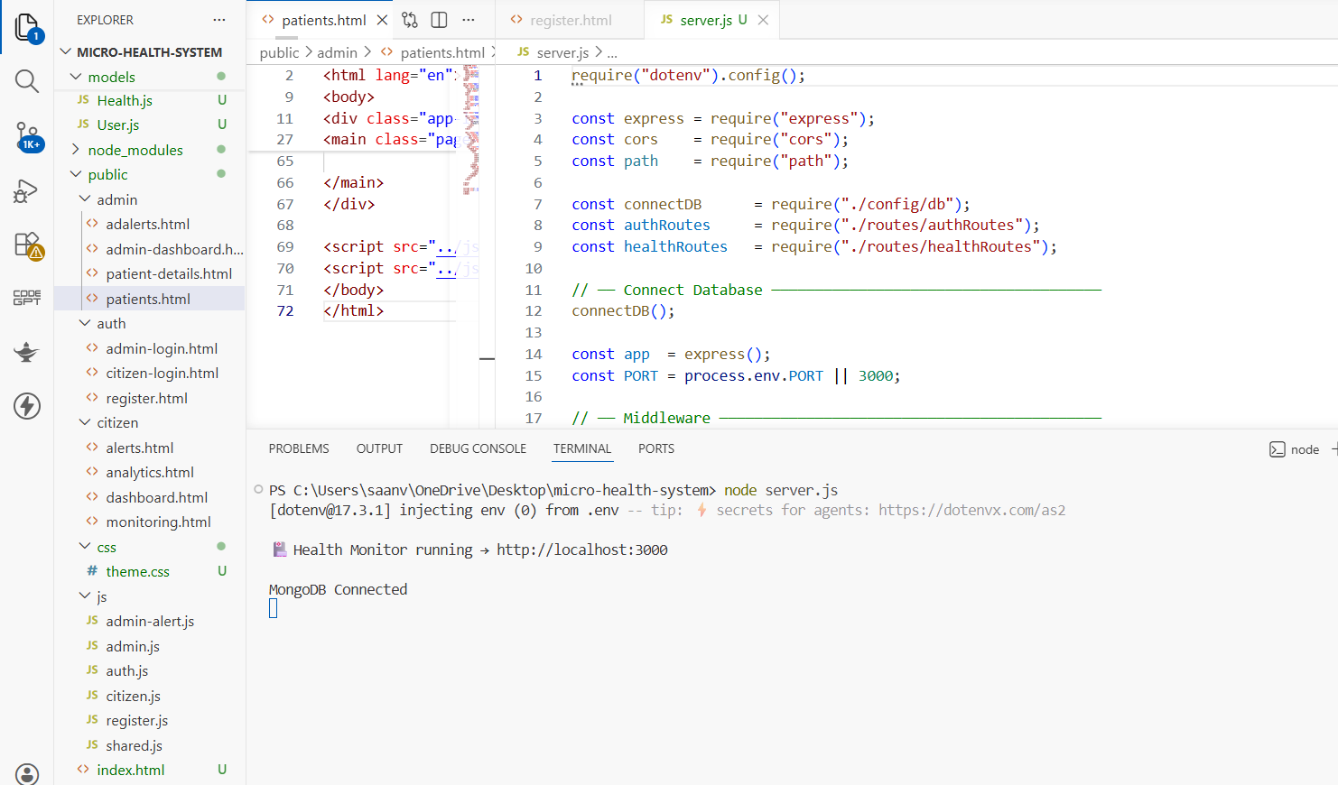
Fig. 7. API Response

E . Risk Output Display
Based on entered details, the system effectively stratifies the users to various risk groups. This is a piece of evidence that the risk evaluation engine is up and running and generating expected outcomes.

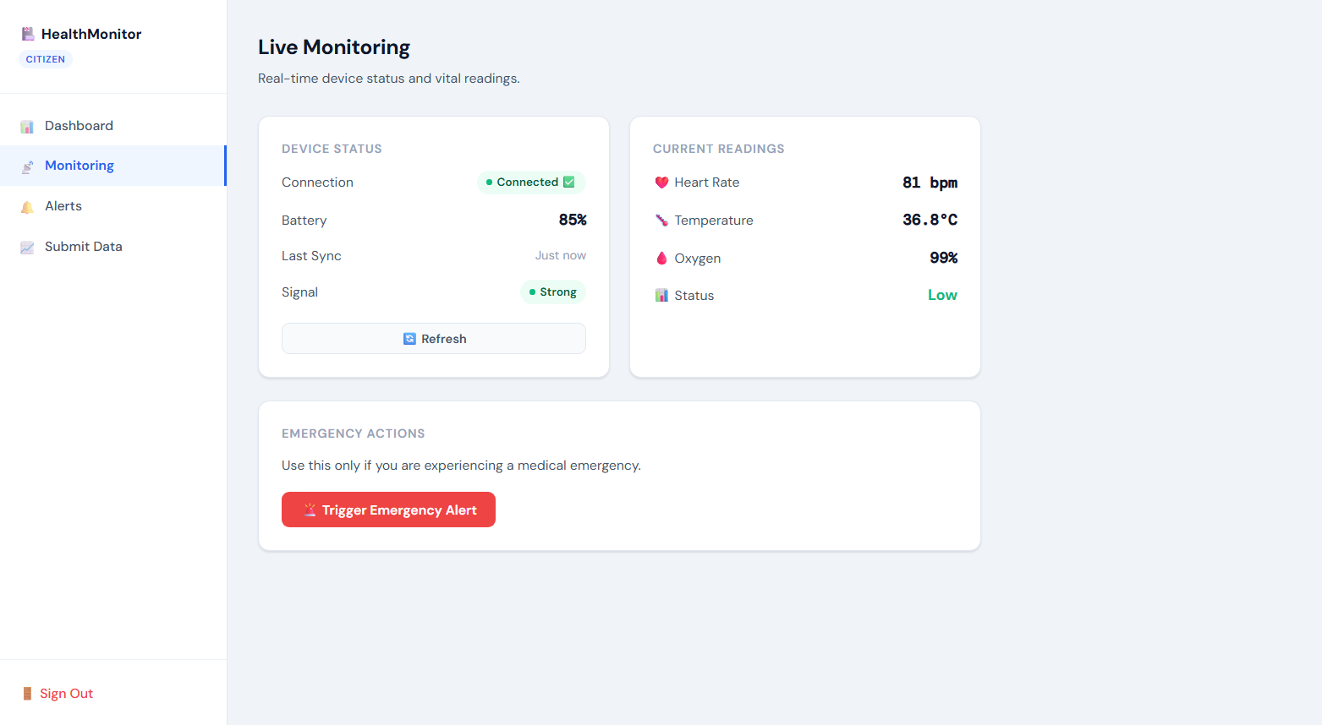
Fig. 8. Risk Output Display

F . Database Storage (Firebase)
All submitted health data, along with risk classifications, is housed in a cloud database. What is shown in the image is that system carries out data storing and retrieving very well, making sure of persistence and scalability.

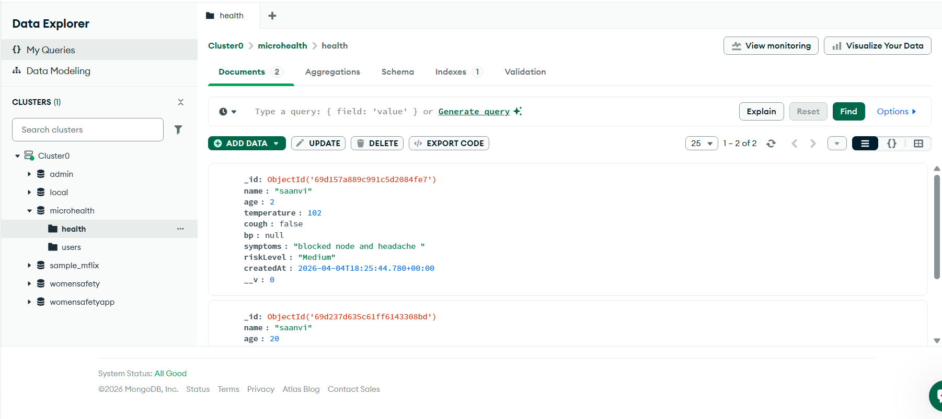
Fig. 9. Firebase Database View

G . Admin Dashboard Monitoring
The admin dashboard offers only one place where you can see all the users with their risk levels. It helps health authorities to keep track of the general health status of the community and focus their attention on those individuals who pose higher risk, thereby proving the efficient merging of the system.

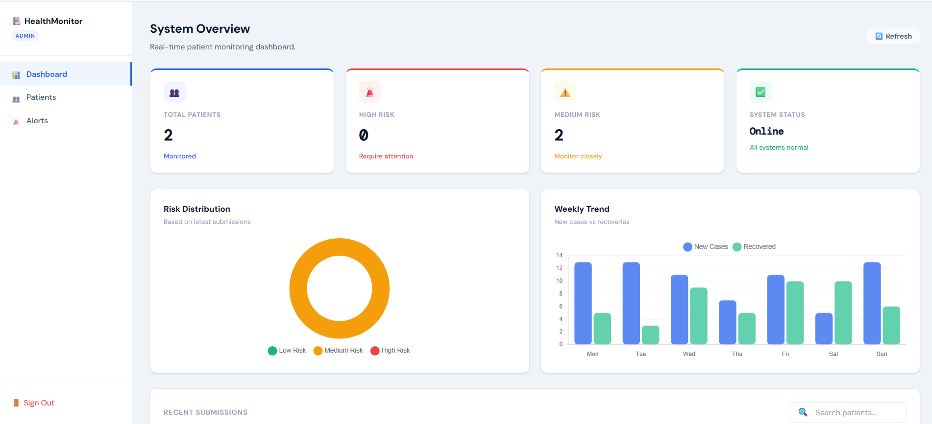
Fig. 10. Admin Dashboard Monitoring

VIII. CONCLUSION
This paper details the planning and building of a Community Micro-Health Monitoring and Alert System that can help detect health risks early at the community level. The paper describes how the system goes beyond simply healthcare ailing detection as the traditional healthcare approach which is mainly reactive in nature. It is a web-based platform that continuously monitors health through regular data input from users.

The rule-based health risk assessment model analyzes the health parameters submitted by users, and based on the analysis, individuals are categorized as low, medium or high-risk. The classification method is a very good way to identify critical cases so that focus can be put on those who need immediate care.With the introduction of an automatic alert system, the platform's response capability is improved even more as it will inform healthcare officials instantly when unhealthy conditions are found.

Experiments and implementation results have verified that the system works effectively in carrying out the primary operations, such as gathering processing storing data, and creating an alert. Running the database on the cloud has made it possible to have storage that is very scalable, dependable, and allows real-time access to data, which aligns well with the system architecture that is modular. User-friendly interface is a great addition as it opens up more possibilities to do activities and encourages community members to actively participate, and that is a must for the success of such monitoring systems.

The simplicity and usability of the proposed system are its major components making it stand out among many others. Relying on the rule-based model is the simplest as no complex machine learning algorithms are needed, which places it perfectly for the environments where resources are limited because of the fast computation and easy implementation capacity.Meanwhile, this system lays a great groundwork for continuing upgrades such as the use of sophisticated predictive models and health monitoring devices based on the Internet of Things (IoT) .[1]

To sum up, this work introduces the Community Micro-Health Monitoring and Alert System as a highly scalable, efficient, and cost-effective method for health monitoring at the community level. By early identifying of health risks and quick reactions to emergencies ,the system is able to help a lot in improving the general health of the population and reducing the strain on healthcare facility. This article serves as a demo of technology being used in a good way to shift healthcare from a reactive model to a preventive one and also aligns greatly with the blueprint of smart and resilient healthcare systems.

VIII. REFRENCES

[1] World Health Organization, “Digital health interventions for health System Strengthening ,” WHO guidelines, 2019.

[2] S. R. Steinhubl, E. D. Muse, and E. J. Topol, “ The emerging field of mobile health ” science translational medicine, vol. 7, no. 283, 2015.

[3] A. Pantelopoulos and N. G. Bourbakis, “A survey on wearable sensor based systems for health monitoring,” IEEE Transactions on systems, man, and cybernetics, vol. 40, no. 1, 2010.

[4] R. Fielding, “Architectural Styles and the Design of network based software architectures,” Doctoral dissertation , University of California , 2000.
(REST API concept).

[5] M. Chen, S. Mao, and Y. Liu, “Big data: A survey,” mobile networks and applications, vol. 19, no. 2, 2014.

.

